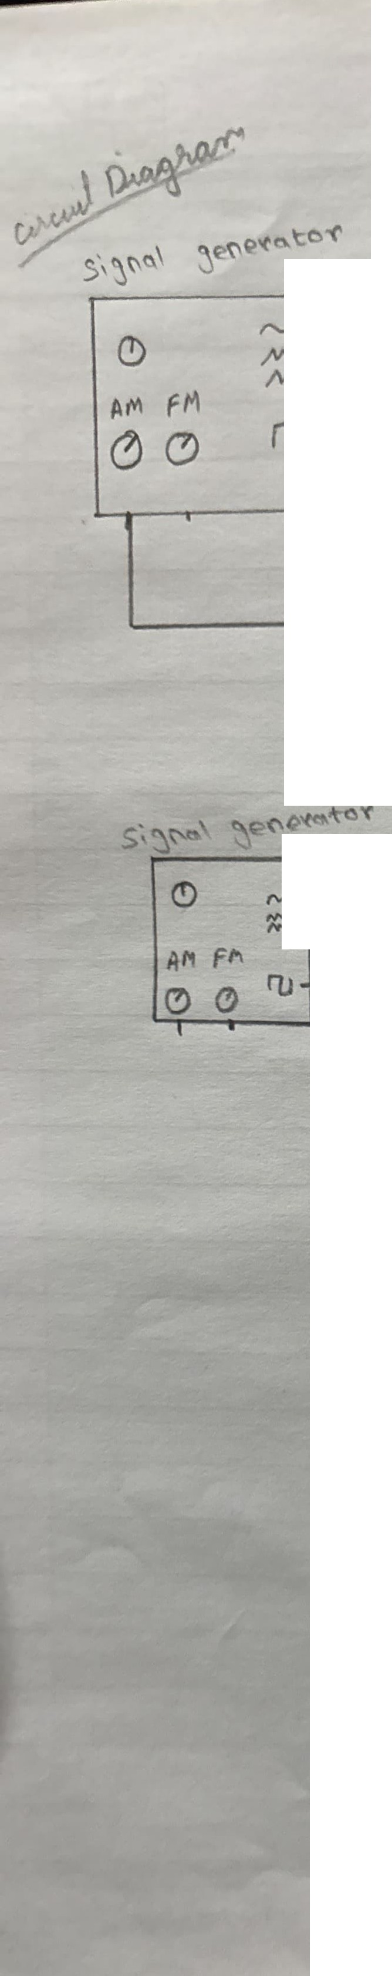
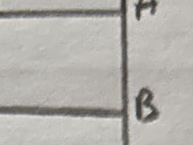


,._,1l-------,.---7
/tN
/'VV
ru...i-----.

C. 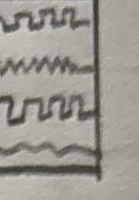
f)

(\, J._----¼-------
�

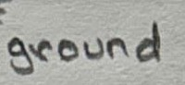
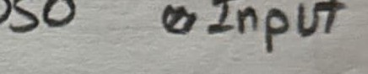
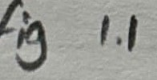

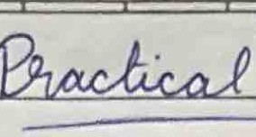
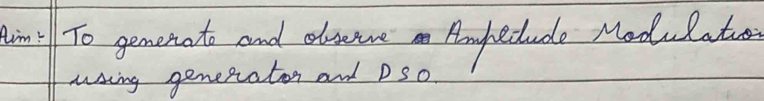
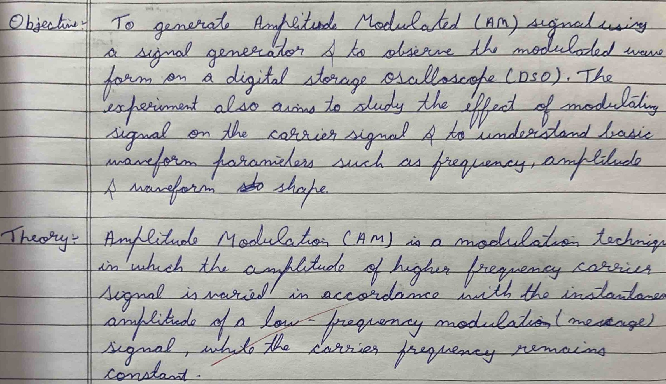
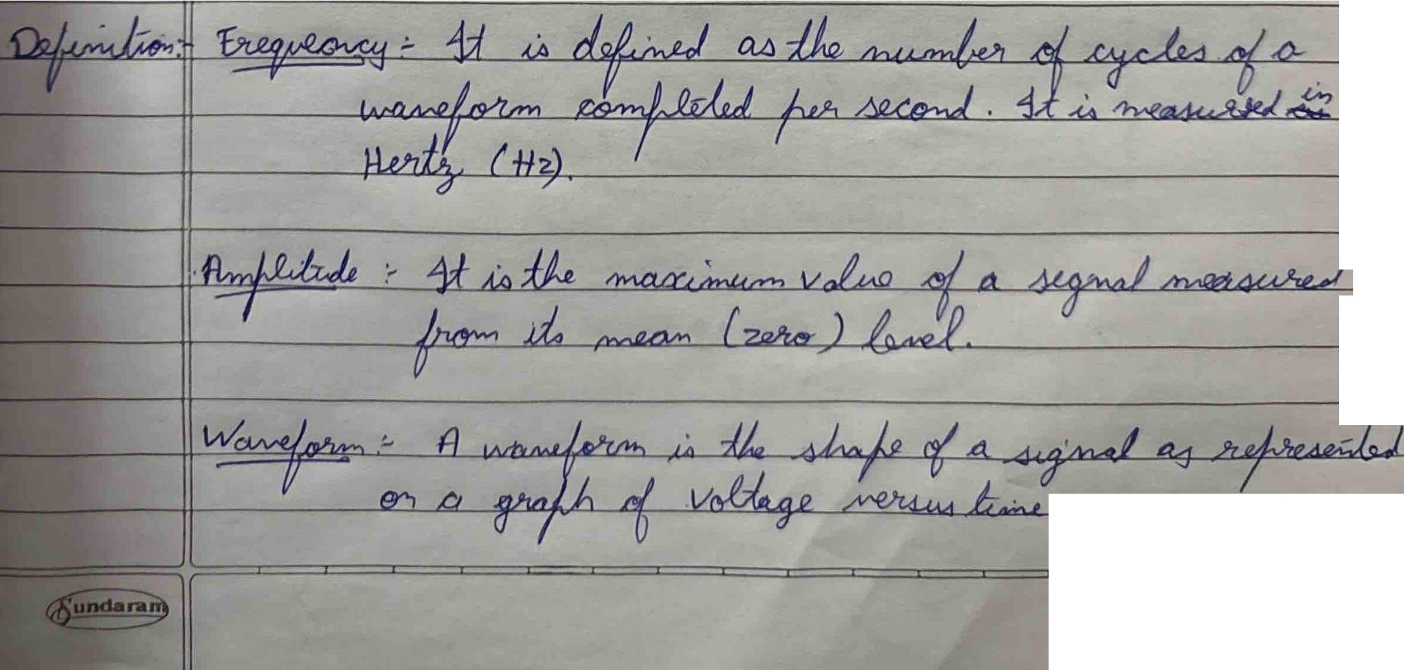
Teacher's Sign. :

EXPERIMENT :
IN°-7 r.......1 o,
L_J ====------- (0a1eI I I
l

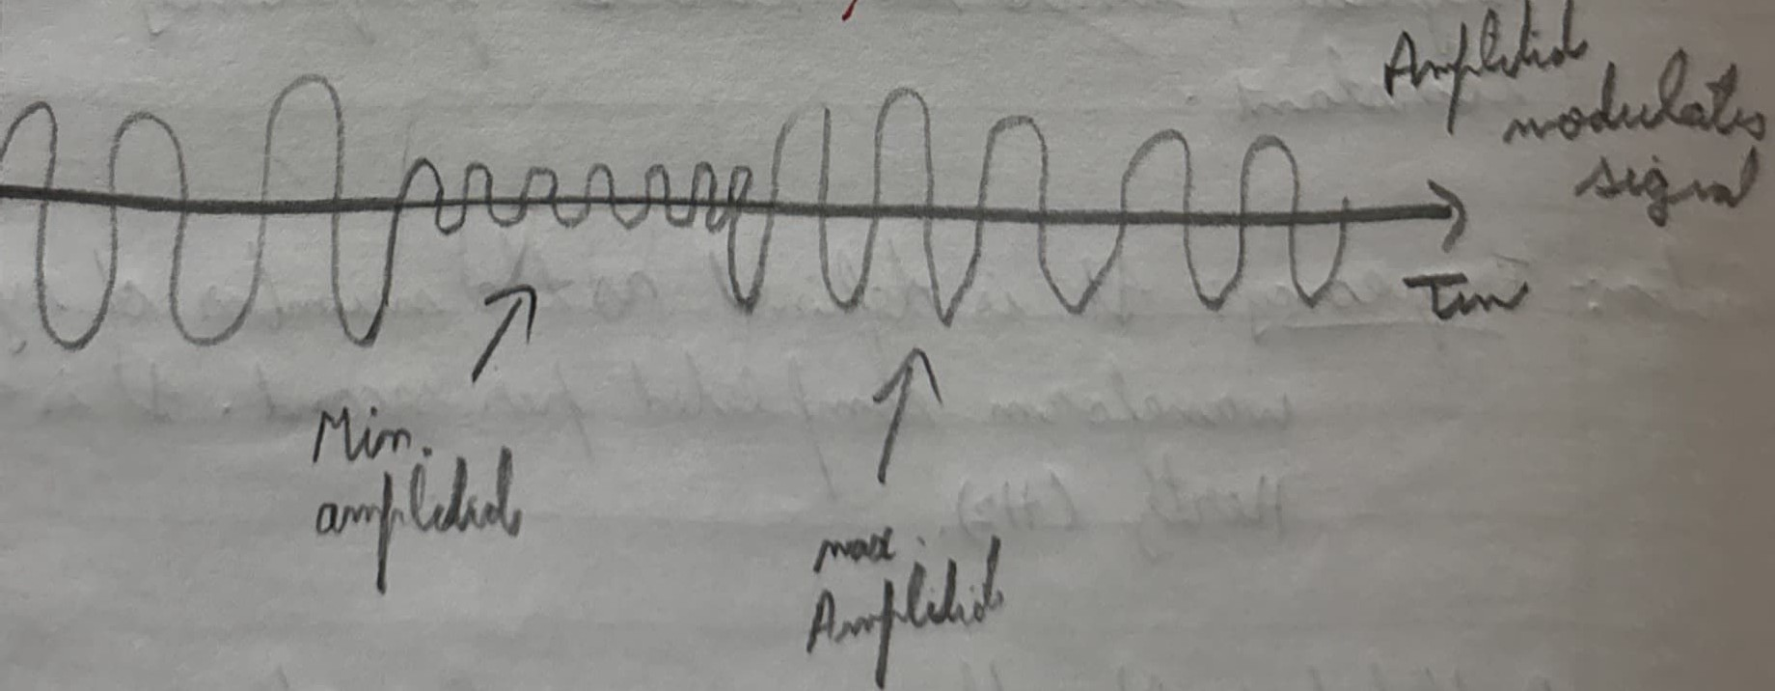


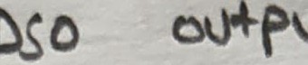

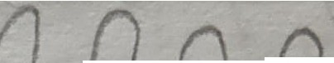
n-t'1-t--+-r-r=-14-1-�-l--l-�-W-.J.J..,..-�rP'�
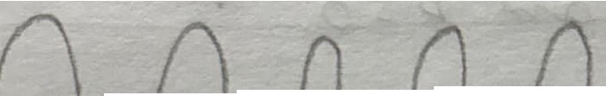
'[�

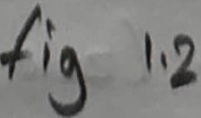

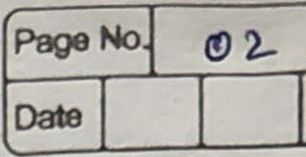
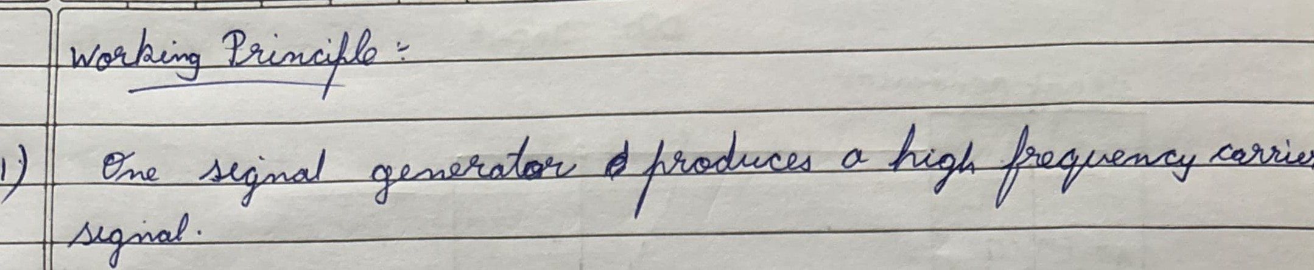
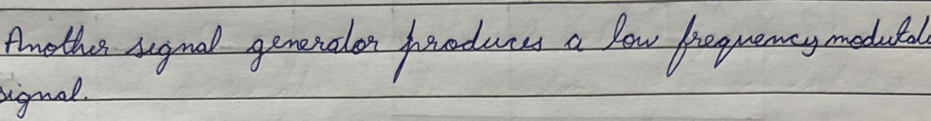
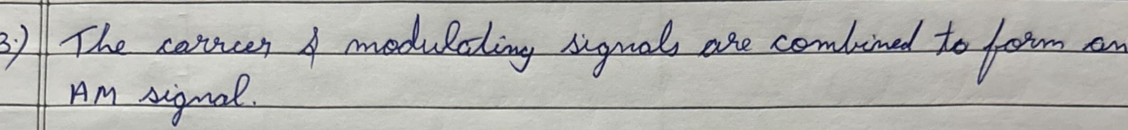
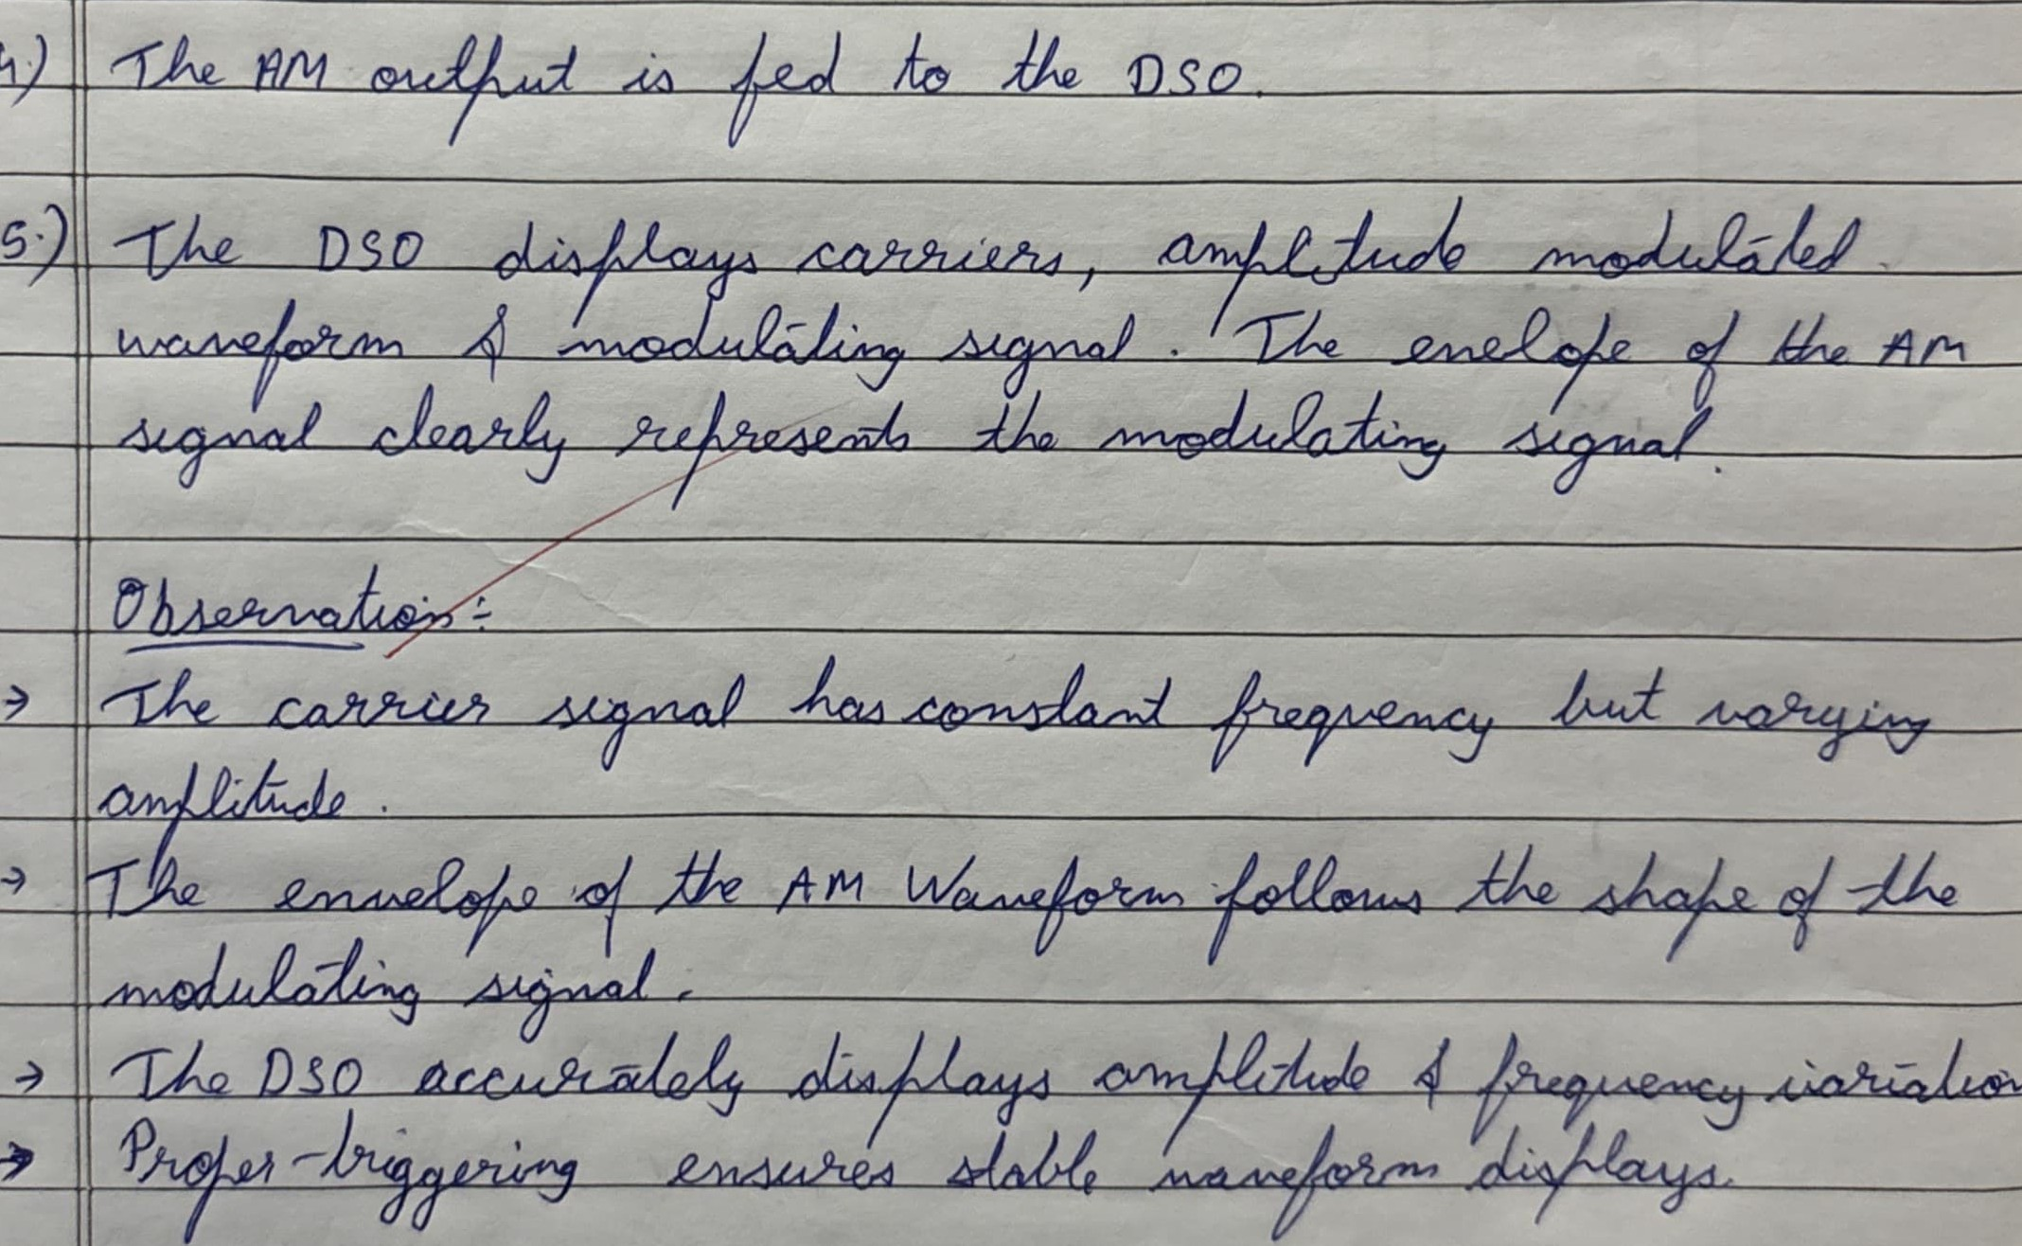
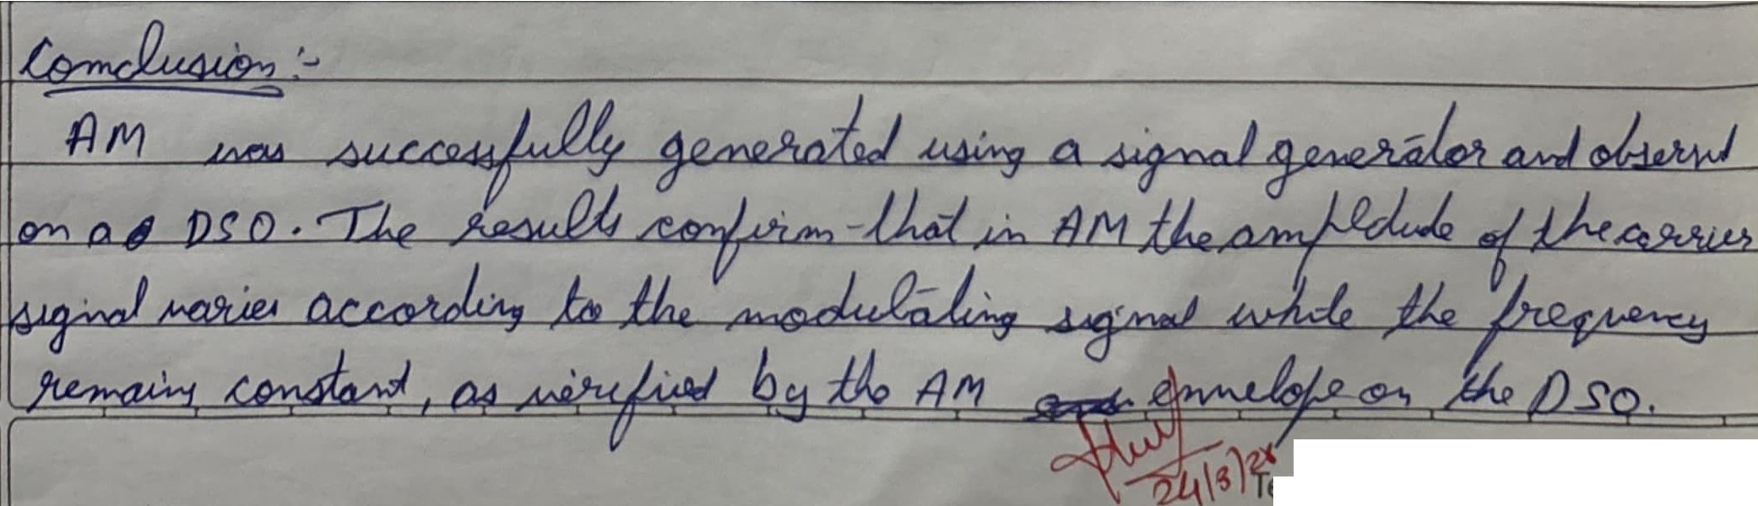
EXPERIMENT : [:] =======-=-------- l

� eacher's Sign. :

